Chrome Hardware Bridge  
(Direct Print Function)  
User Manual

**Introduction**

“Chrome Hardware Bridge” enables silent print to multiple printers without PDF download or user confirmation.

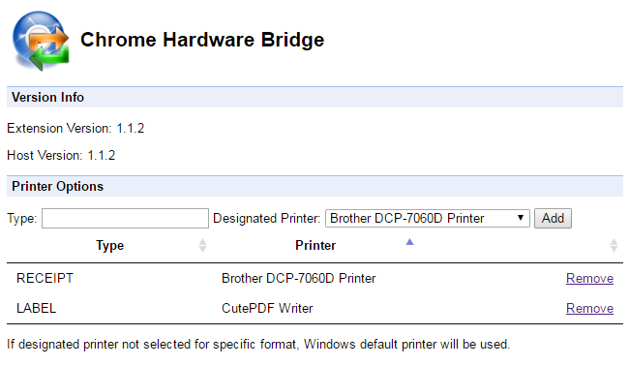

**System Requirement**

* Windows Vista or higher
* Intel Core i3 or equivalent
* 2GB of RAM
* Internet/Intranet Access to Web App
* Google Chrome 28 or later (Auto-installed if needed)
* Adobe Reader XI or higher (Auto-installed if needed)

**Document Version**

1.1.2 (2016-04-11)

**Installation**

1. Launch Setup executable  
     
   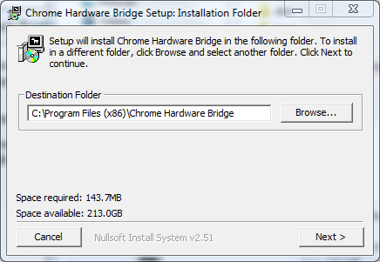
2. Click “Next >”  
   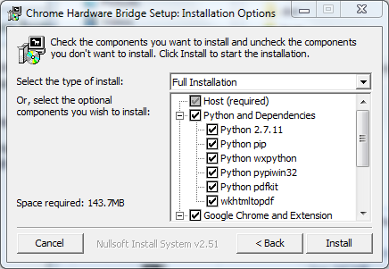
3. For new installation, choose “Full Installation”.  
   For upgrade, choose “Host, Dependencies and Extension Only”

And click “Install”, wait until installation complete, click “Close”

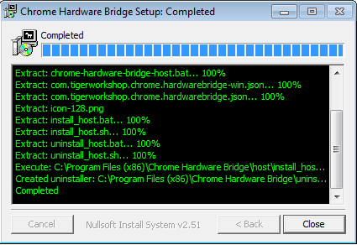

1. Launch “Chrome”, it should detect new extension installed   
   Click on the message and enable the extension (If nothing show up, go to next step)  
   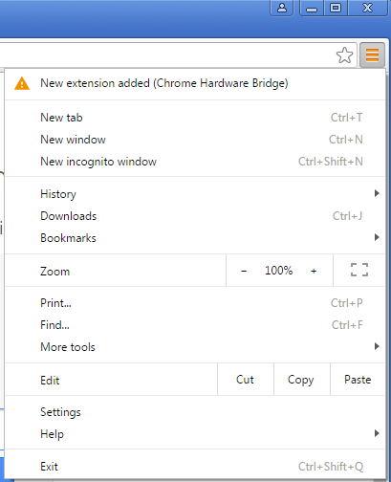
2. Select “Menu”, click “More Tools > Extensions“, check if “Chrome Hardware Bridge” is enabled  
   If not, click “Enabled” to enable it.  
     
   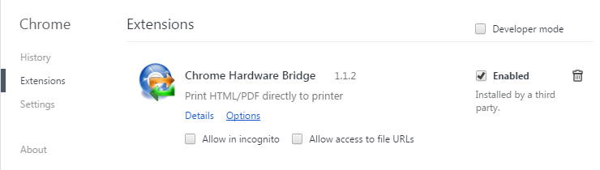
3. Click “Options” on “Chrome Hardware Bridge”. Check if “Host Version” is shown correctly.  
   Add printer mapping as needed.   
   Enter “Type” according to your project setup.



1. Setup completed.